**Power Plant > Substation:**

1. **Transformer:**
2. **Power Transformer**: We provide power transformer upto 132kV, 80/120MVA for power grid, power plant, solar power plant etc.

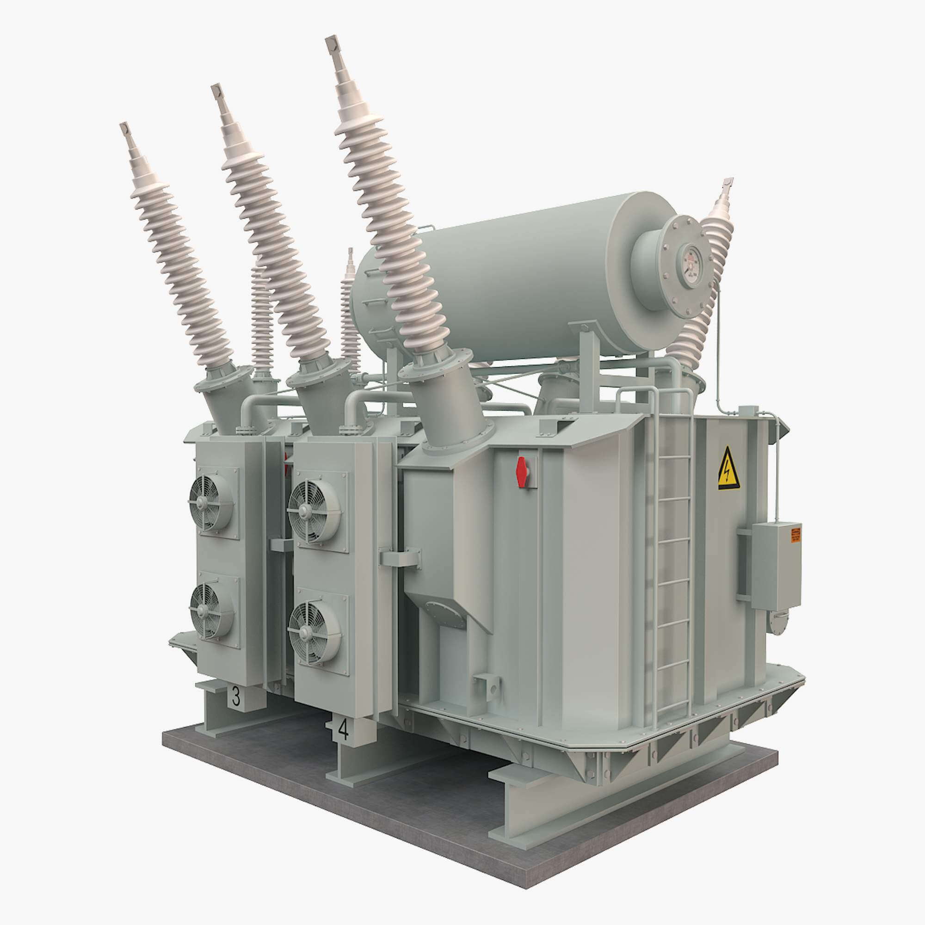

**Key Features:**

1. **High Voltage Capacity**: Designed to handle voltages up to 132kV, ensuring compatibility with large-scale power transmission systems.

2. **Large Power Rating**: Offering capacities like 80/120MVA to meet the demands of high-power loads.

3. **Efficiency**: Engineered for minimal energy losses, ensuring optimal performance and cost-effectiveness.

4. **Durability**: Built with robust materials to withstand extreme weather conditions and prolonged operation.

5. **Advanced Cooling Systems**: Equipped with oil or air cooling systems for efficient heat dissipation and prevention of overheating.

6. **Low Noise Operation**: Designed with mechanisms to reduce noise levels, ensuring quieter operation in various environments.

7. **Overload Capability**: Able to handle temporary overloads without compromising performance.

8. **Customizability**: Can be tailored to specific project requirements, such as solar power integration or unique grid configurations.

9. **Safety Features**: Includes protections against short circuits, overvoltage, and surges to enhance operational safety.

10. **Compliance with Standards**: Certified to meet international standards like IEC, ANSI, or IEEE, ensuring quality and reliability.

1. **Distribution Transformer:**

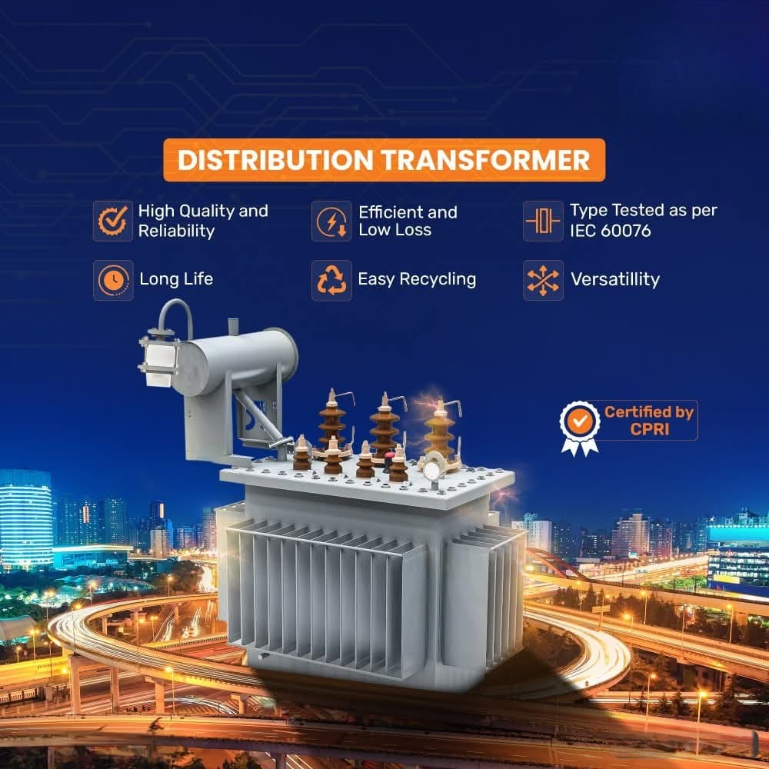

We supply and manufacture distribution tranformers upto 11kV, 5000kVA for commercial and residential projects**.** Distribution transformers play a key role in delivering electricity from the power grid to end users, such as homes, businesses, and small industries. They step down high voltage from transmission lines to a lower, usable voltage level. Here are some highlights:

**Key Features:**

Distribution transformers play a key role in delivering electricity from the power grid to end users, such as homes, businesses, and small industries. They step down high voltage from transmission lines to a lower, usable voltage level. Here are some highlights:

**\*\*Key Features of Distribution Transformers\*\***

1. **Voltage Step-Down**: Typically convert voltages from 11kV or higher down to the standard voltage levels used in residential or industrial setups, like 230V or 400V.

2. **Compact Design**: Smaller and more lightweight compared to power transformers, making them easy to install in local areas.

3. **High Efficiency at Low Load**: Designed to perform optimally even at lower load levels typical in neighborhoods.

4. **Cooling Systems**: Usually air-cooled or oil-cooled, depending on their capacity and application.

5. **Mounting Options**: Can be pole-mounted, pad-mounted, or placed underground.

6. **Reliability**: Designed for continuous operation with minimal maintenance.

7. **Low Noise**: Operates quietly, suitable for urban and residential environments.

8. **Safety Features**: Includes protection against overload, short circuits, and environmental factors.

Distribution transformers ensure safe and reliable electricity delivery to consumers. If you'd like more details on specific types or need support showcasing them, let me know!

1. **Cast Resin Transformers:**

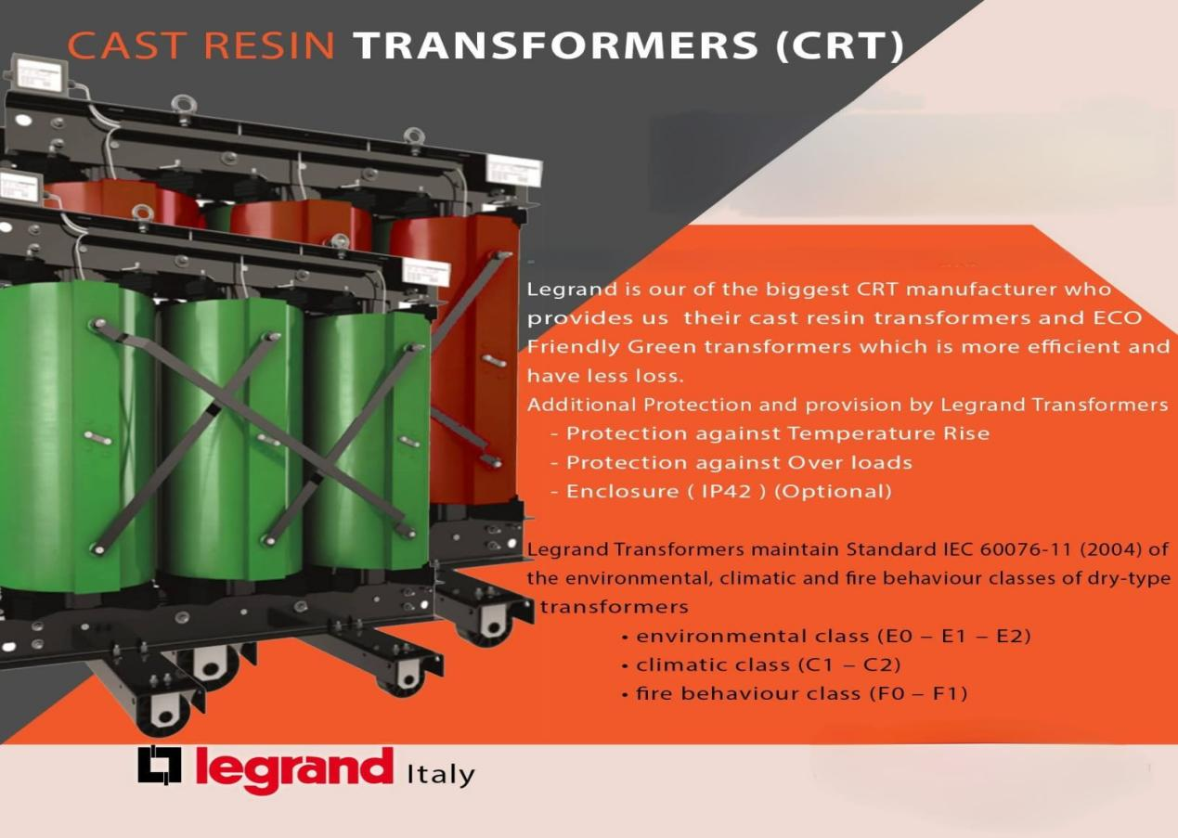

**Key Features:**

**Cast resin transformers** are a type of dry-type transformer known for their reliability, safety, and environmental friendliness. Here's an overview of their features and benefits:

### **Key Features**

1. **Epoxy Resin Insulation**: The windings are encapsulated in epoxy resin, providing excellent protection against moisture, dust, and pollutants.

2. **Fire Resistance**: Non-flammable and self-extinguishing, making them ideal for indoor applications and areas with high fire risk.

3. **Low Maintenance**: Require minimal upkeep due to their robust design and lack of oil-based cooling systems.

4. **Compact Design**: Suitable for installations in confined spaces, such as commercial buildings and industrial facilities.

5. **High Mechanical Strength**: Can withstand thermal and mechanical stresses, including short circuits and load cycling.

6. **Eco-Friendly**: No risk of oil leaks, reducing environmental impact.

7. **Cooling Options**: Typically cooled by natural air (AN) or forced air (AF), ensuring efficient heat dissipation.

### **Applications**

- Commercial and residential buildings

- Industrial facilities

- Renewable energy projects

- High-risk areas like chemical plants and tunnels

1. **MV Switchgrear:**

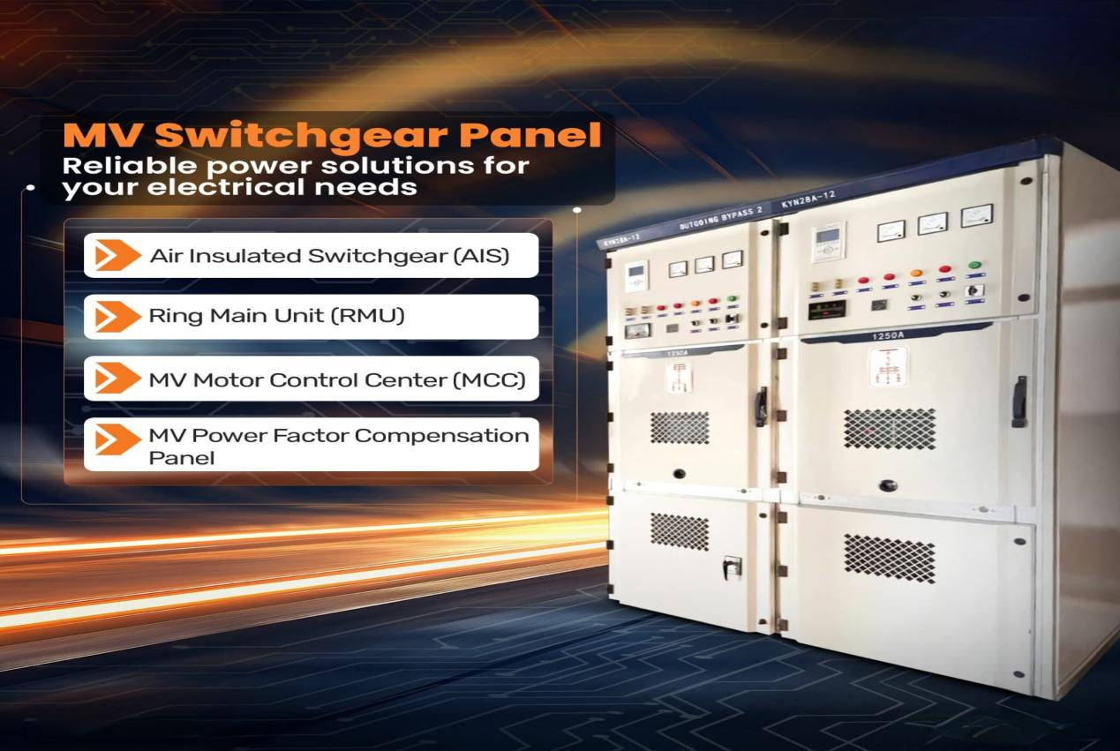

**Key Features:**

Medium Voltage (MV) Switchgear is essential for managing and protecting electrical systems operating between 1kV and 36kV. Here are its **key features**:

**IEC 62271 Series**: Addresses high-voltage switchgear and controlgear, including general specifications and testing.

1. **Voltage Range**: Operates efficiently within the medium voltage range of 1kV to 36kV.

2. **Advanced Protection**: Equipped with protective relays and circuit breakers to safeguard against faults like overloads and short circuits.

3. **Durable Design**: Built to withstand harsh industrial and outdoor environments.

4. **Automation Capabilities**: Often integrated with SCADA systems for remote monitoring and control.

5. **Compact and Modular**: Designed for easy installation and scalability in various applications.

6. **Safety Features**: Includes isolators, earthing switches, and arc fault protection for enhanced operational safety.

7. **Low Maintenance**: Requires minimal upkeep due to robust construction and reliable components.

8. **Versatility**: Suitable for diverse applications, including industrial plants, commercial buildings, and utility substations.

1. **LV Switchgear: (LT Panel, MCC Panel, PFI Panel)**

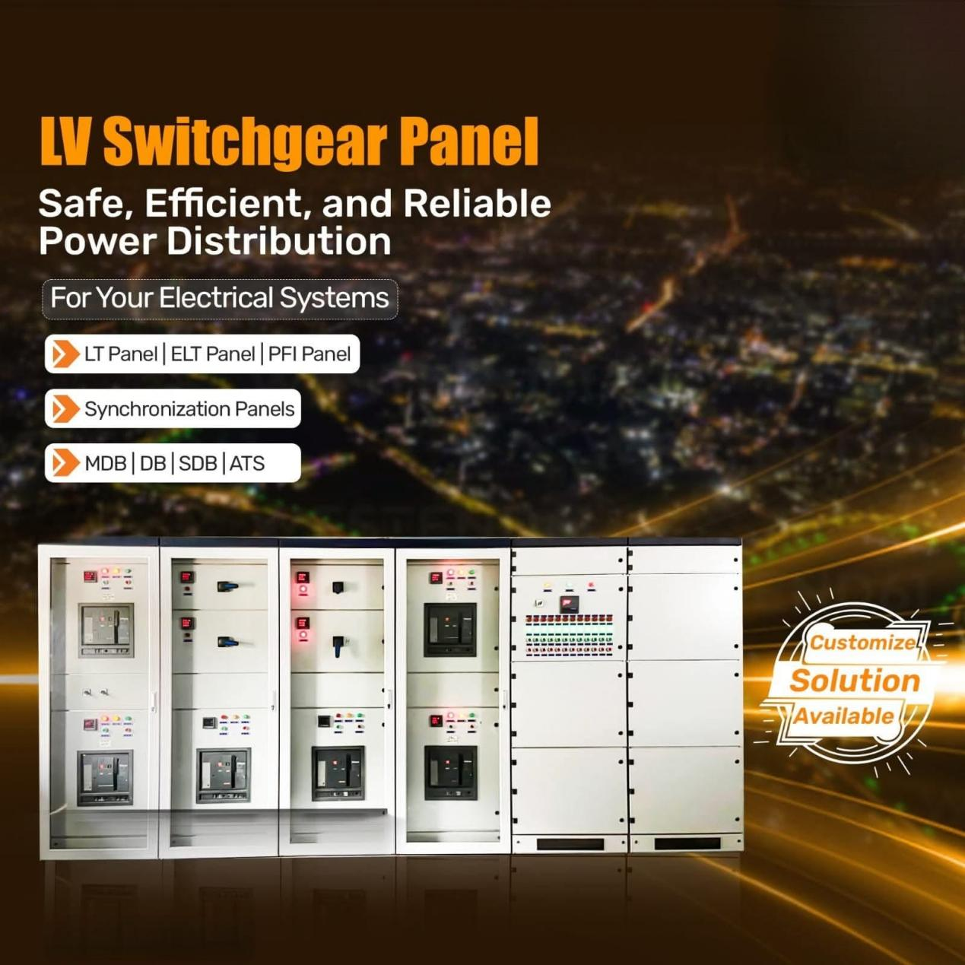

**Key Features:**

• **IEC 60947 Series**: Covers low-voltage switchgear and controlgear, including circuit breakers, switches, and motor starters.

• • **IEC 61439 Series**: Specifies requirements for low-voltage switchgear assemblies, emphasizing design verification and safety.

Here are the **key features** of Low Voltage (LV) Switchgear, aligned with IEC standards for safety and reliability:

1. **Voltage Range**: Operates at voltages up to 1,000V, suitable for distribution in residential, commercial, and industrial facilities.

2. **Protection Systems**: Integrates circuit breakers, relays, and fuses to guard against overloads, short circuits, and earth faults.

3. **Modular Design**: Offers flexibility for easy expansion and customization to meet specific operational needs.

4. **Compact and Space-Saving**: Designed for efficient use of space while maintaining accessibility for maintenance.

5. **High Safety Standards**: Includes arc fault protection, interlocking systems, and insulation barriers to enhance operator safety.

6. **Automation-Ready**: Can be equipped with communication systems for remote monitoring and control, supporting smart grid and industrial automation.

7. **Durable Construction**: Resistant to heat, humidity, and other environmental conditions, ensuring a long operational lifespan.

8. **Efficient Power Distribution**: Minimizes energy loss and ensures reliable performance under various load conditions.

9. **User-Friendly Maintenance**: Accessible compartments and clear labeling simplify servicing and reduce downtime.

10. **Compliance with Standards**: Designed and tested in accordance with IEC 61439 to ensure quality and reliability.

**04. Medium Voltage Circuit Breakers:**

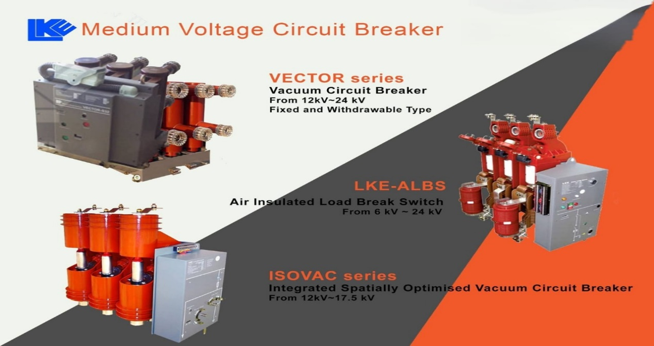

Medium Voltage (MV) circuit breakers are essential for controlling and protecting electrical circuits in medium voltage systems. Here are some key features:

1. **Types of Circuit Breakers**:
   * **Vacuum Circuit Breakers**: Known for their long contact life, low maintenance, and high reliability.
   * **SF6 Gas Circuit Breakers**: Effective for high voltage applications but require careful handling due to environmental concerns.
   * **Air-Magnetic Circuit Breakers**: Older technology, less common today.
2. **Key Components**:
   * **Arc Extinguishers**: Help in safely interrupting the electrical arc during fault conditions.
   * **Operating Mechanisms**: Include stored energy systems like springs or magnetic techniques for quick operation.
   * **Contact Assemblies**: Ensure reliable electrical connections and disconnections.
3. **Ratings and Standards**:
   * Rated voltage, current, and short-circuit capacity.
   * Compliance with IEC or ANSI standards for safety and performance.
4. **Control and Protection**:
   * Integrated with protection relays and current transformers for automatic tripping during faults.
   * Can be operated locally or remotely for flexibility.
5. **Mounting Options**:
   * Fixed or draw-out designs for ease of maintenance and replacement.

These features make MV circuit breakers indispensable in industrial, commercial, and utility applications. If you'd like to dive deeper into any specific aspect, let me know!

**05. MDB, SDB, ASDB, LDB, FDB Panel:**

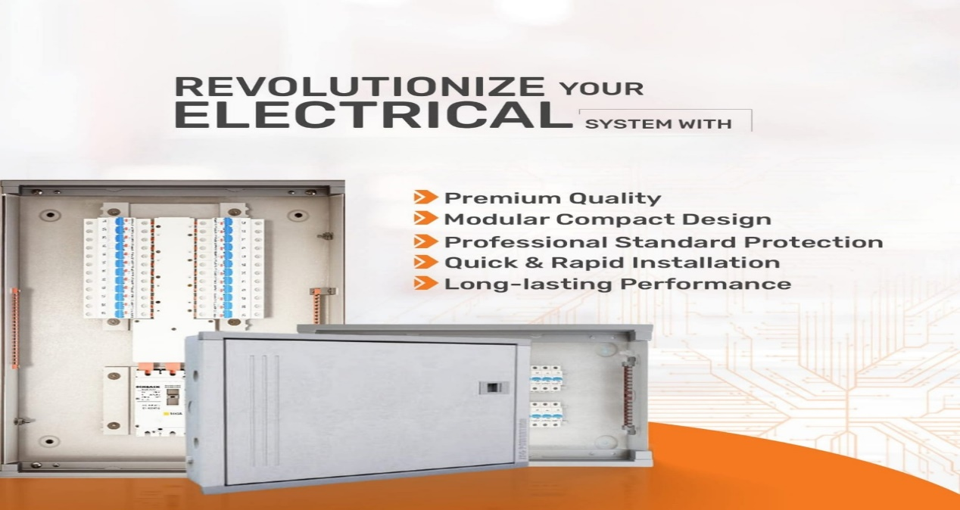

Here are the key features of **SDB (Sub Distribution Boards)** and **MDB (Main Distribution Boards)**:

**SDB (Sub Distribution Boards)**

* **Purpose**: Distributes power from the Main Distribution Board to localized areas or specific circuits.
* **Compact Design**: Smaller and more compact compared to MDBs, suitable for localized power distribution.
* **Circuit Protection**: Houses circuit breakers, fuses, and residual current devices for safety.
* **Customization**: Can be tailored to specific applications, such as lighting or HVAC systems.
* **Ease of Maintenance**: Modular design allows for easy access and maintenance.

**MDB (Main Distribution Boards)**

* **Central Hub**: Acts as the main point for receiving and distributing electricity from the transformer or utility.
* **High Capacity**: Rated up to 4000A and operating voltage up to 690V.
* **Safety Standards**: Fully type-tested assemblies as per IEC 61439-1.
* **Construction**: Available in Form 2, Form 3, and Form 4 configurations.
* **Protection**: Includes main circuit breakers, earth leakage protection, and IP-rated enclosures (IP42 to IP54).
* **Flexibility**: Supports top and bottom cable entry, with options for front or rear access.

Both SDBs and MDBs play crucial roles in ensuring safe and efficient power distribution in electrical systems. Let me know if you'd like to explore any specific aspect further!

**06. CABLE TRAYS**

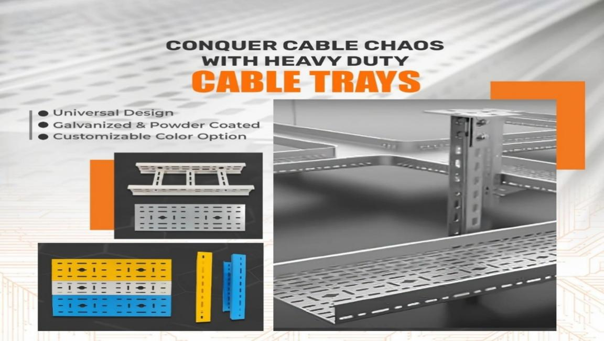

Cable trays are essential components in electrical systems, providing a structured pathway for organizing and protecting cables. Here are their key features:

1. **Types**:
   * **Ladder Cable Tray**: Offers excellent ventilation and heat dissipation, ideal for industrial environments.
   * **Perforated Cable Tray**: Features holes for ventilation, providing moderate protection and support.
   * **Wire Mesh Cable Tray**: Lightweight and promotes airflow, commonly used in IT and telecommunication setups.
   * **Solid Bottom Cable Tray**: Provides full protection from external elements like dust and moisture.
2. **Materials**:
   * Made from steel, aluminum, or fiberglass, often with anti-corrosion coatings for durability.
3. **Sizes**:
   * Available in various widths, heights, and lengths to suit different applications.
4. **Applications**:
   * Used in industrial plants, data centers, commercial buildings, and transport hubs for efficient cable management.
5. **Advantages**:
   * Prevents overheating and cable damage.
   * Simplifies maintenance and future modifications.
   * Enhances safety by reducing clutter and tripping hazards.

Cable trays are versatile and indispensable for maintaining order in complex wiring environments. Let me know if you'd like to explore any specific type or feature further!

=======================================================================================================================

**07. GENERATOR**

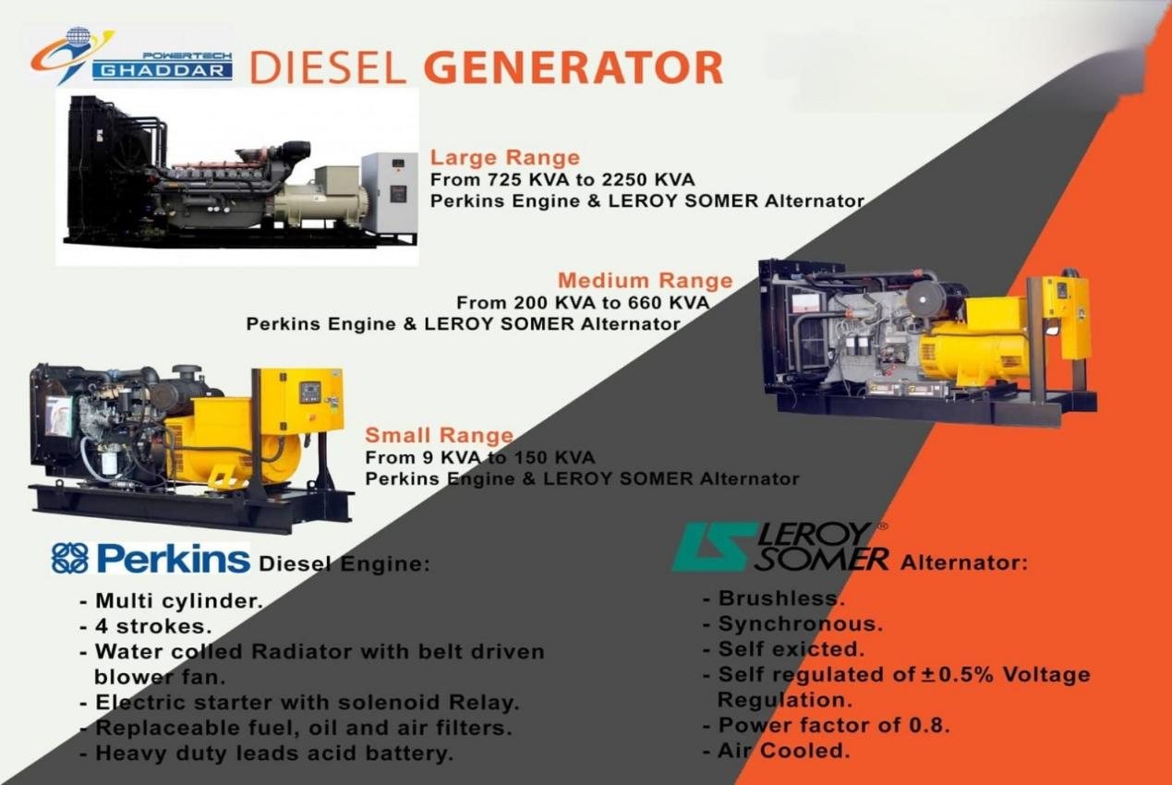

Generators are crucial devices for producing electrical power in the absence of a direct power supply. Here are their key features:

1. **Types of Generators**:
   * **Standby Generators**: Provide backup power during outages.
   * **Portable Generators**: Lightweight and mobile, suitable for temporary or remote use.
   * **Industrial Generators**: Designed for large-scale, high-power applications.
2. **Power Output**:
   * Rated based on wattage (kW or MW) to suit different needs, from household use to industrial facilities.
3. **Fuel Types**:
   * Common fuels include diesel, gasoline, natural gas, and propane. Some modern generators also support renewable sources like solar.
4. **Key Components**:
   * **Engine**: Converts fuel into mechanical energy.
   * **Alternator**: Converts mechanical energy into electrical energy.
   * **Control System**: Manages the generator's operation, including starting, stopping, and monitoring.
   * **Cooling System**: Prevents overheating during operation.
5. **Efficiency & Features**:
   * Automatic transfer switch (ATS) for seamless power supply during outages.
   * Noise-reduction technology in modern designs.
   * Remote monitoring and control in advanced models.
6. **Safety & Standards**:
   * Equipped with overload protection and safety shutdown features.
   * Adherence to industry standards like ISO and IEC.

Generators are indispensable for ensuring an uninterrupted power supply in various scenarios. If you'd like, I can expand on any specific aspect!

**============================================================**

**Power Backup >> Auto Voltage Regulator ( AVR )**

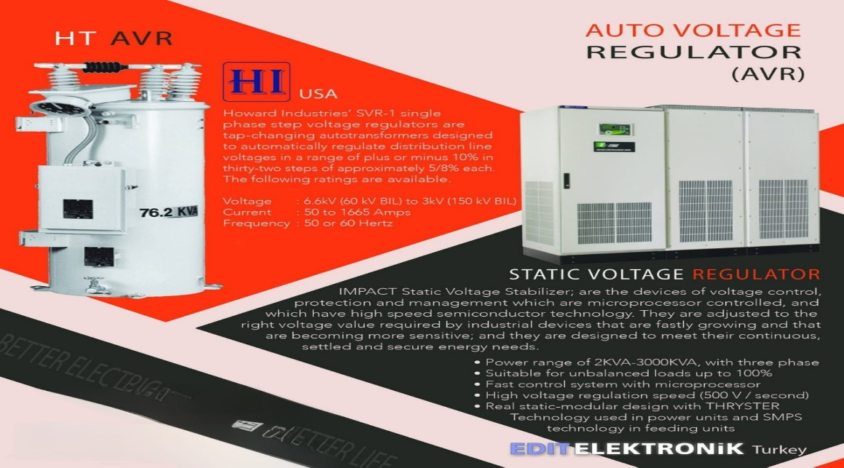

Automatic Voltage Regulators (AVRs) are essential devices for maintaining stable voltage levels and protecting electronic equipment. Here are some key features of AVRs:

1. **Voltage Stabilization**: AVRs ensure a constant voltage supply by automatically adjusting fluctuations to a set value.
2. **Wide Voltage Range**: They can regulate large voltage ranges, adapting to various electrical network conditions.
3. **Fast Response Time**: AVRs quickly detect and correct voltage variations, often with regulation speeds of 20 Volts/sec.
4. **Compatibility**: They are versatile and can be used with lighting systems, industrial machinery, and other equipment.
5. **Efficiency**: AVRs minimize energy loss during regulation, contributing to energy efficiency.
6. **Protection**: They safeguard devices from overvoltage, undervoltage, and sudden voltage spikes.

These features make AVRs indispensable for ensuring the longevity and reliability of electronic devices. Are you considering getting one for a specific application?